Chanceller Waters

assignment 1.2

Link to repository

https://github.com/cwaters-00/csd2.git

Screenshot
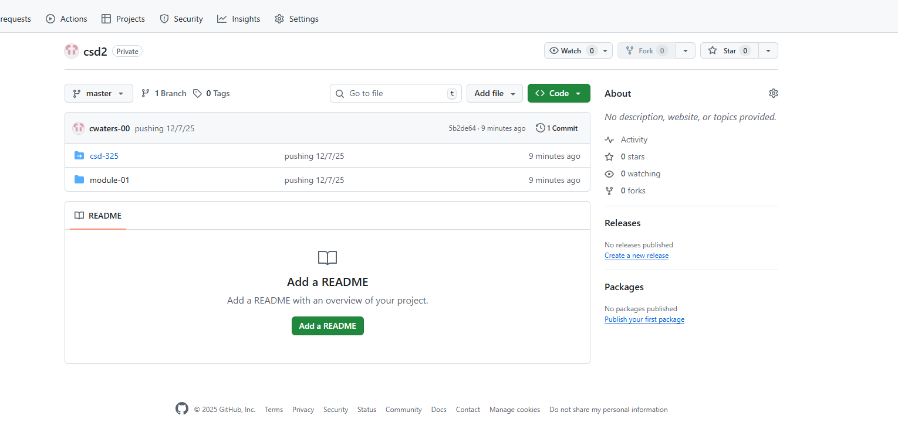

Directory screenshot

